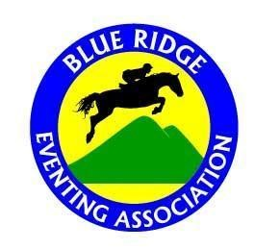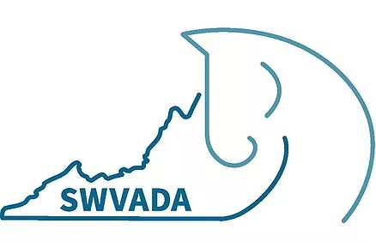
Blue Ridge Eventing Association & Southwest Virginia Dressage Association Horse Trials, Combined Tests & Dressage Tests
May 5, 2024 ….. Closing Date: April 26, 2024
Green Hill Park Equestrian Center, Salem, VA www.breventing.org
Levels Offred:
Horse Trials: Tadpoles – Novice Plus
Combined Tests : Tadpoles – Preliminary
Dressage Tests: 2023 USDF/USEF Intro thru Second Level, 2022 USEF Eventing Tests thru Preliminary, WDAA Western dressage tests, Working Equitation Level 1 thru Level 7
CT Specifications:
Tadpole*** | 2023 USDF Intro Test A, Western Dressage Intro Level 1; ground poles
Cross Rails**: | 2023 USDF Intro Test B; Jumps 18” max
Green*: | 2023 USDF Intro Test C; Jumps 2’ max
Advanced Green: | 2022 USEA Starter Test; Jumps 2’3” max
Beg. Novice: | 2022 USEF Beginner Novice Test A; Jumps 2’7” max
Novice: | 2022 USEF Novice Test A; Jumps 2’11” max
Novice Plus: | 2022 USEF Training Test A: Jumps 3’3” max.
Training: | 2022 USEF Training Test A; Jumps 3’3” max
Modi ed: | 2022 USEF Modi ed Test A; Jumps 3’5” max
Preliminary:  HT Specifications: | 2022 USEF Preliminary Test A; Jumps 3’7” max
Tadpole*** | 2023 USDF Intro Test A, Western Dressage Intro Level 1; ground poles
Cross Rails**: | 2023 USDF Intro Test B; Jumps 18” max
Green*: | 2023 USDF Intro Test C; Jumps 2’ max
Advanced Green: | 2022 USEA Starter Test; Jumps 2’3” max
Beg. Novice: | 2022 USEF Beginner Novice Test A; Jumps 2’7” max
Novice: | 2022 USEF Novice Test A; Jumps 2’11” max
Novice Plus: | 2022 USEF Modi ed Test A: Jumps 3’3” max.
Dressage Judge: Beth Sproule “L”
Entry Fees  Horse Trials:  Combined Tests:  Dressage Tests:  Offi ce Fee:  Stabling: | BREA/SWVADA Members  $75 $40  $25  $5  $20 | Non-Members  $95 $55  $35  $5  $20 (Stalls must be cleaned after use)

Entry Submission:
- Entries should be made on the online form on the home page at breventing.org. Entries should include Entry Information, BREA Waiver, USEA Release and a current negative Coggins test (within 12 months of show date).
- Payment will be accepted by snail mail check only at this time- we apologize for the inconvenience. Checks must be made out to BREA and mailed to the address below and received before the closing date (APRIL 26th) to be considered complete . Incomplete entries may be placed on a waiting list.
Kelly Linn 396 Orrix Creek Road Evington, Va 24550-3908
- Late entries MAY be accepted and a $10 late fee charged, at the Show Secretary’s discretion. Scratches prior to the closing date will receive a full refund less a $10 office fee. After the closing date, NO refunds will be given. Entries may have to sign additional liability waivers the day of the show.
Show Secretary: Kelly Linn – breasecretary@gmail.com 434-609-3505
Show Managers/Volunteer Coordinator: Gammon Castellvi (BREA) – gammonlee@gmail.com
Laura Nelson (SWVADA) – galliard.laura7@gmail.com

Directions to GHPEC: 2961 Harborwood Road, Salem, VA, 24153
Exit 137 o I-81. Turn towards Salem on Wildwood Road. At intersection with Route 11/460, turn right. Go through two lights. At third light, turn left onto Duiguids Lane. Cross RR tracks and pass rst entrance to Green Hill Park. Go another mile to the Equestrian Center trailer entrance on your right. There is separate entrance for vehicles not pulling a trailer further down the road.
Other information: Starting times will be emailed to competitors and will also be posted on www.breventing.org on the Thursday before the show. All riders, competing or non-competing, at all times on the competition grounds must wear a riding helmet which meets or exceeds ASTM (American Society for Testing and Materials)/SEI (Safety Equipment Institute) standards for equestrian use and carries the SEI tag. The headgear and harness must be secured and properly tted. Any rider violating this rule at any time will immediately be prohibited from further riding until such headgear is properly in place. At all horse trials, riders will ride their stadium round & then report immediately to cross country, thus riders should ride their stadium round in cross country attire. All dogs MUST be leashed. Owners of impounded dogs will be fined $35. Dress is casual, but neat and tidy. Half chaps are allowed. Body protective vests are required for cross country. Medical armbands must be worn when jumping. Ribbons will be awarded up to and including 6th place. Horse Trials & Combined Test divisions will be divided into Junior/Young Rider & Senior, unless there are 2 or fewer in a division. If no age is stated on the entry form, it will be assumed that the rider is a Senior competitor (over 18). Show management reserves the right to combine, divide, or cancel classes as entries warrant. USEF rules will be followed unless otherwise noted by show management. Horses competing in a horse trial may only enter additional dressage tests (no additional jumping phases allowed). No more than 2 consecutive levels of Combined Tests may be entered. Paid schooling rounds are only permitted after the entry has completed their judged jumping round(s). The cross country course will be open for walking at 3pm the day before the show; course maps will be available under the pavilion the morning of the show, and on CourseWalk.com the day before. There will be NO CONCESSIONS at this event…please bring your own food and water.***Tadpole division is COACHABLE in all three phases.
**Cross Rails division is COACHABLE in the jumping phases only.
*Green division is COACHABLE on cross country only.
One coach is allowed, other outside assistance is not permitted in Tadpole, Cross Rails or Green.
Please see rules for all divisions at https://breventing.org/levels

